Create Deep Entity:

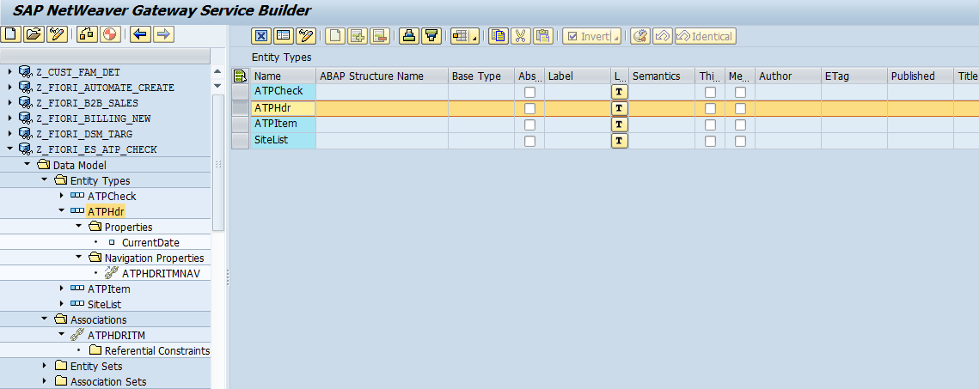

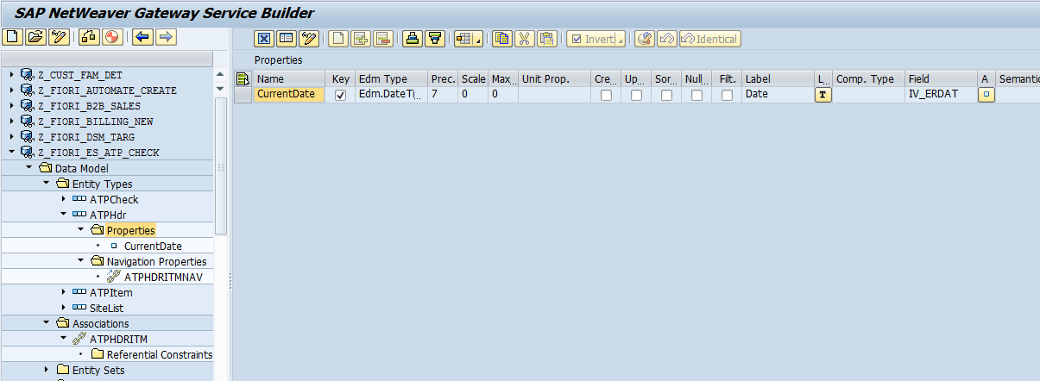

ATPItemSet:

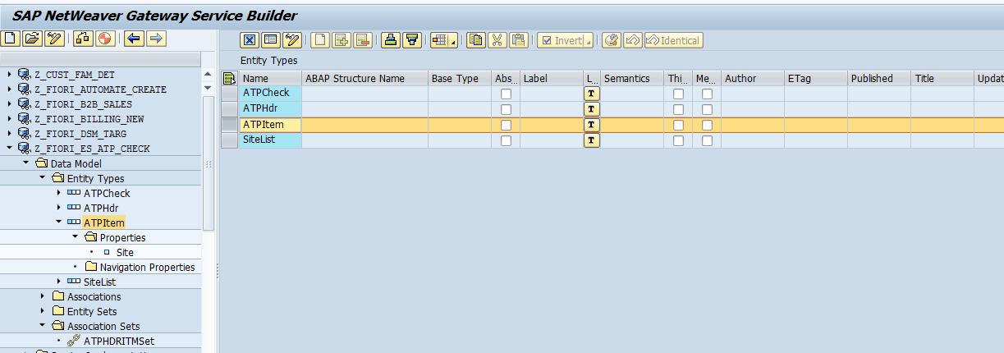

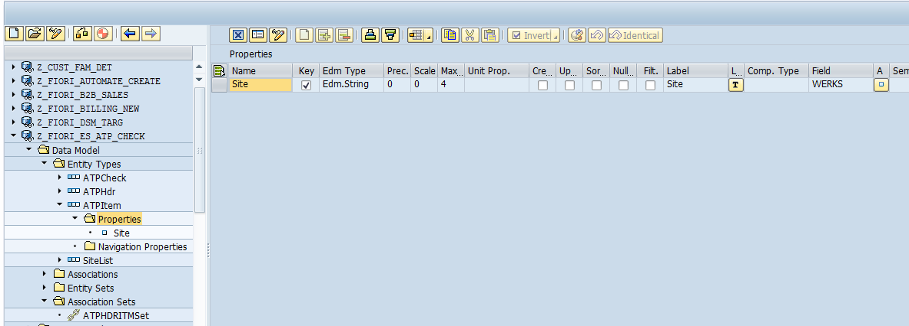

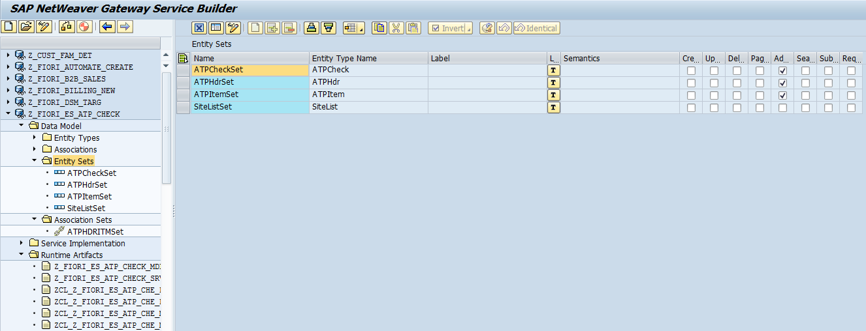

Associations:

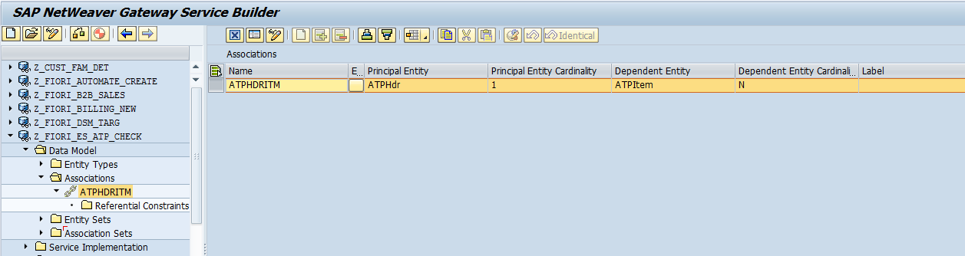

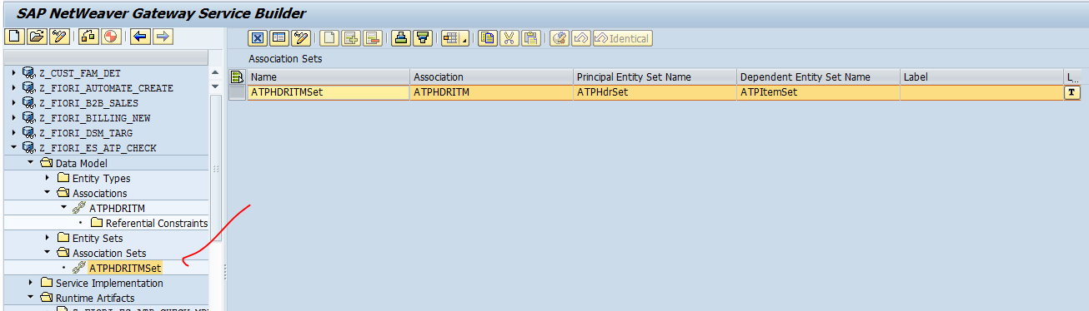

Signatute:

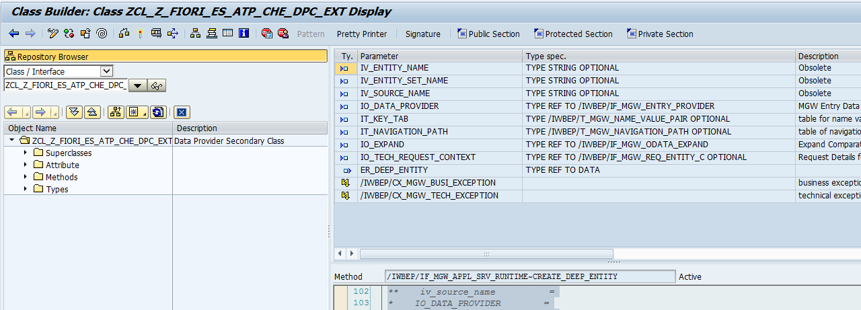

Code:

Method /IWBEP/IF_MGW_APPL_SRV_RUNTIME~CREATE_DEEP_ENTITY.

  TYPES : BEGIN OF ty_headitem.  
  INCLUDE        TYPE zcl_z_fiori_es_atp_che_mpc=>ts_atphdr.  
  TYPES : atphdritmnav TYPE STANDARD TABLE OF zcl_z_fiori_es_atp_che_mpc=>ts_atpitem WITH DEFAULT KEY,  
          END OF ty_headitem.  
  
  DATA  : lw_headitem      TYPE ty_headitem,  
          lv_date TYPE dats,  
          lw_item TYPE zcl_z_fiori_es_atp_che_mpc=>ts_atpitem,  
          ls_item TYPE werks,  
          lt_item TYPE wrf_pbas_werks_tty.  
  
  DATA   :   lv_flag    TYPE abap_bool VALUE space,  
            lw_lheader TYPE ihttpnvp,  
            json       TYPE string,  
            lo_message TYPE REF TO zcl_fiori_format_message_json.  
  
  CONSTANTS: lc_e TYPE char01 VALUE 'E',  
             lc_w TYPE char01 VALUE 'W',  
             lc_i TYPE char01 VALUE 'I',  
             lc_s TYPE char01 VALUE 'S'.  
  
  DATA    :  lt_return    TYPE STANDARD TABLE OF bapiret2,  
             lw_return    TYPE bapiret2,  
             lo_container TYPE REF TO /iwbep/if_message_container.  
  
  io_data_provider->read_entry_data( IMPORTING es_data = lw_headitem ).  
  
  IF lw_headitem IS NOT INITIAL.  
    lv_date = lw_headitem-iv_erdat = sy-datum.  
  
    LOOP AT lw_headitem-atphdritmnav INTO lw_item.  
      ls_item-werks = lw_item-werks.  
      APPEND ls_item TO lt_item.  
      CLEAR ls_item.  
    ENDLOOP.  
  ENDIF.  
  
  CALL FUNCTION 'ZSTO_AVCKCHECK'  
   EXPORTING  
*     IT_EBELN        =  
     IT_WERKS        = lt_item  
     IV_ERDAT        = lv_date  
   IMPORTING  
     ET_RETURN       = lt_return.  
  
  IF lt_return IS NOT INITIAL.  
    CLEAR: lw_return, lv_flag.  
    LOOP AT lt_return INTO lw_return WHERE type = lc_s  
                                        OR type = lc_i  
                                        OR type = lc_w.  
      lv_flag = abap_true.  
      EXIT.  
    ENDLOOP.  
  
    IF lv_flag IS INITIAL.  
      lo_container = me->mo_context->get_message_container( ).  
      CLEAR lw_return.  
      LOOP AT lt_return INTO lw_return.  
        CALL METHOD lo_container->add_message  
          EXPORTING  
            iv_msg_type   = lw_return-type  
            iv_msg_id     = lw_return-id  
            iv_msg_number = lw_return-number  
            iv_msg_text   = lw_return-message  
            iv_msg_v1     = lw_return-message_v1  
            iv_msg_v2     = lw_return-message_v2  
            iv_msg_v3     = lw_return-message_v3  
            iv_msg_v4     = lw_return-message_v4.  
      ENDLOOP.  
  
      RAISE EXCEPTION TYPE /iwbep/cx_mgw_busi_exception  
        EXPORTING  
          message_container = lo_container.  
    ELSE.  
      CREATE OBJECT lo_message.  
      CALL METHOD lo_message->message_format  
        EXPORTING  
          im_returnmsg = lt_return  
        IMPORTING  
          ex_json      = json.  
  
      lw_lheader-name = 'sap-message'.  
      lw_lheader-value = json.  
      set_header( is_header = lw_lheader ).  
    ENDIF.  
  ENDIF.  
  
  CALL METHOD me->copy_data_to_ref  
    EXPORTING  
      is_data = lw_headitem  
    CHANGING  
      cr_data = er_deep_entity.  
  
**TRY.  
*CALL METHOD SUPER->/IWBEP/IF_MGW_APPL_SRV_RUNTIME~CREATE_DEEP_ENTITY  
*  EXPORTING  
**    iv_entity_name          =  
**    iv_entity_set_name      =  
**    iv_source_name          =  
*    IO_DATA_PROVIDER        =  
**    it_key_tab              =  
**    it_navigation_path      =  
*    IO_EXPAND               =  
**    io_tech_request_context =  
**  IMPORTING  
**    er_deep_entity          =  
*    .  
** CATCH /iwbep/cx_mgw_busi_exception .  
** CATCH /iwbep/cx_mgw_tech_exception .  
**ENDTRY.

Endmethod.

Get expand Enity set

**Get Expand Entity**

**HDR 🡪ITEM**

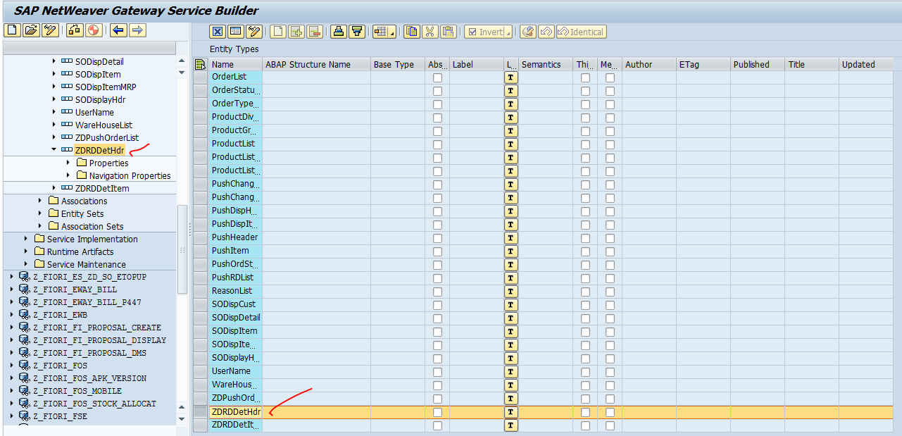

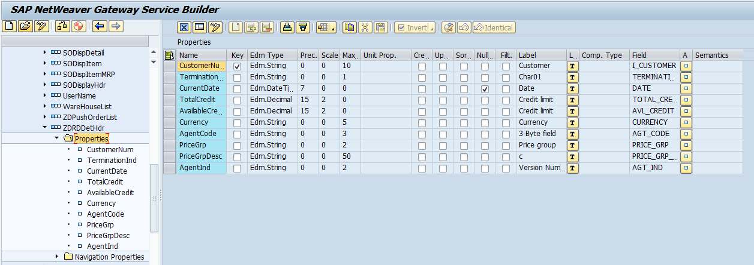

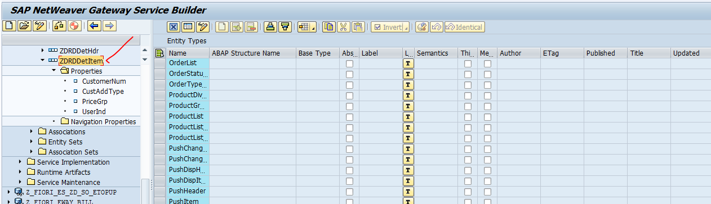

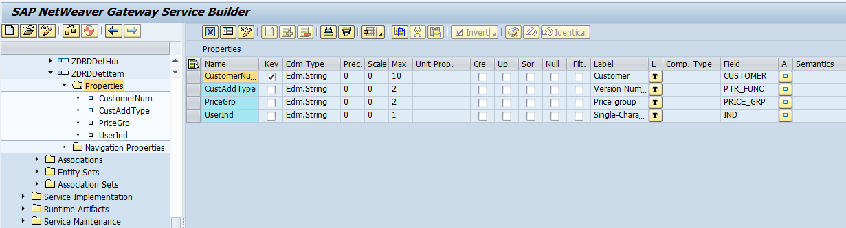

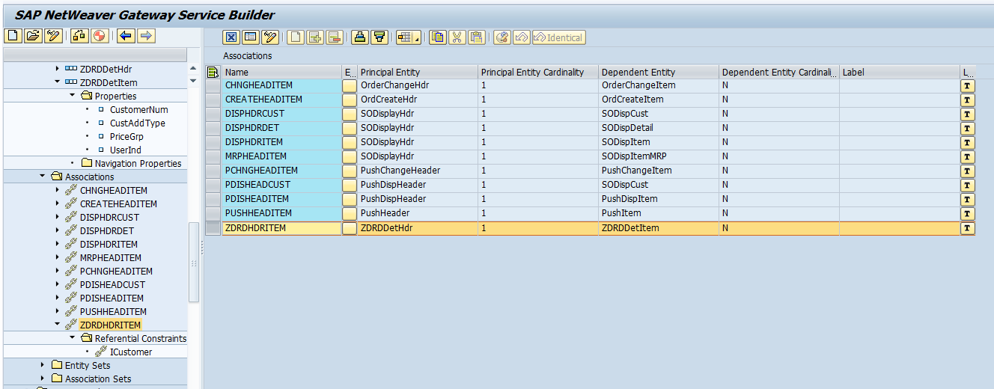

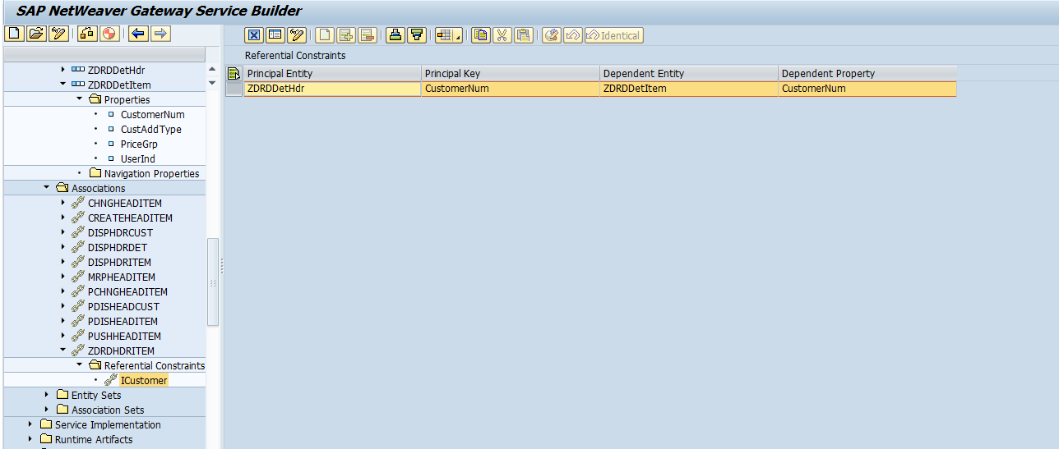

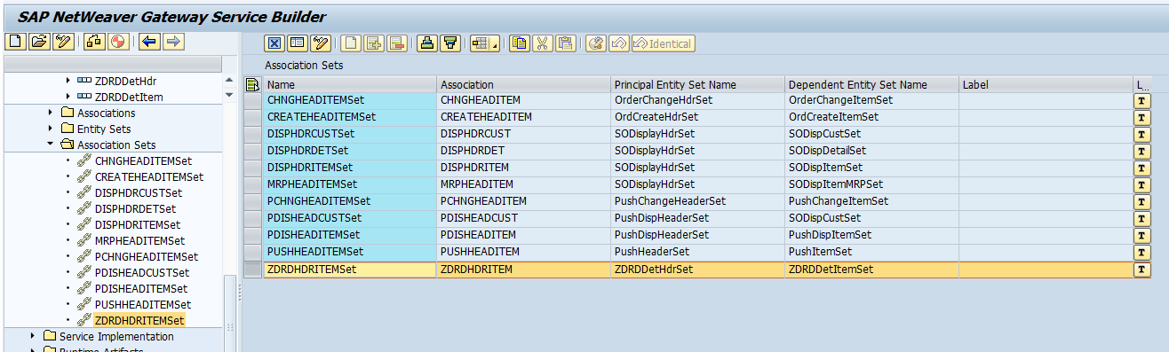

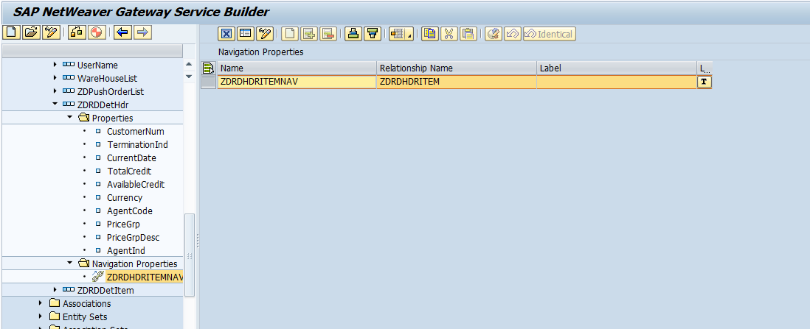

METHOD /iwbep/if_mgw_appl_srv_runtime~get_expanded_entity.  
  
  DATA:     lw_return     TYPE bapiret2,  
            lt_return     TYPE STANDARD TABLE OF bapiret2,  
            ls_key_tab    TYPE /iwbep/s_mgw_name_value_pair,  
            lo_container  TYPE REF TO /iwbep/if_message_container.  
  
  CONSTANTS: lc_e TYPE char01 VALUE 'E'.  
  
  IF iv_entity_set_name = 'ZDRDDetHdrSet'.  
  
    TYPES    : BEGIN OF ty_headitem.  
    INCLUDE        TYPE   zcl_z_fiori_es_so_crea_mpc=>ts_zdrddethdr.  
    TYPES    : zdrdhdritemnav TYPE   zso_customer_tt,  
               END OF ty_headitem.  
  
  
    DATA     : lv_customer   TYPE kunnr,  
               ls_header     TYPE zso_credit_dtl_st,  
               ls_headitem   TYPE ty_headitem,  
               ter_ind       TYPE char01.  
  
    CONSTANTS : lc_expand_tech_clause TYPE string VALUE 'ZDRDHDRITEMNAV'.  
  
    READ TABLE it_key_tab INTO ls_key_tab WITH KEY name = 'CustomerNum'.  
    lv_customer = ls_key_tab-value.  
  
*    CALL FUNCTION 'ZSO_FETCH_ZDRD'  
*      EXPORTING  
*        i_customer = lv_customer  
*      IMPORTING  
*        et_return  = lt_return  
*        et_output  = ls_headitem-zdrdhdritemnav  
*        es_header  = ls_header  
*        TERMINATION_IND = ter_ind.  
    CALL FUNCTION 'ZSO_FETCH_ZDRD'  
      EXPORTING  
        i_customer      = lv_customer  
      IMPORTING  
        et_return       = lt_return  
        et_output       = ls_headitem-zdrdhdritemnav  
        es_header       = ls_header  
        termination_ind = ter_ind.  
  
  
    ls_headitem-agt_code       = ls_header-agt_code.  
    ls_headitem-avl_credit     = ls_header-avl_credit.  
    ls_headitem-currency       = ls_header-currency.  
    ls_headitem-date           = ls_header-date.  
    ls_headitem-i_customer     = ls_header-customer.  
    ls_headitem-price_grp      = ls_header-price_grp.  
    ls_headitem-price_grp_desc = ls_header-price_grp_desc.  
    ls_headitem-total_credit   = ls_header-total_credit.  
    ls_headitem-agt_ind        = ls_header-agt_ind.  
    ls_headitem-termination_ind        = ter_ind.  " ankit on 26-06-18  
  
    IF lt_return IS NOT INITIAL.  
      lo_container = me->mo_context->get_message_container( ).  
      CLEAR lw_return.  
      LOOP AT lt_return INTO lw_return WHERE type = lc_e.  
        CALL METHOD lo_container->add_message  
          EXPORTING  
            iv_msg_type   = lw_return-type  
            iv_msg_id     = lw_return-id  
            iv_msg_number = lw_return-number  
            iv_msg_text   = lw_return-message  
            iv_msg_v1     = lw_return-message_v1  
            iv_msg_v2     = lw_return-message_v2  
            iv_msg_v3     = lw_return-message_v3  
            iv_msg_v4     = lw_return-message_v4.  
      ENDLOOP.  
  
      RAISE EXCEPTION TYPE /iwbep/cx_mgw_busi_exception  
        EXPORTING  
          message_container = lo_container.  
    ENDIF.  
  
    copy_data_to_ref(    EXPORTING is_data = ls_headitem  
                         CHANGING cr_data  = er_entity ).  
  
    INSERT lc_expand_tech_clause INTO TABLE et_expanded_tech_clauses.

Endif.

Endmethod.

GET_EXPANDED_ENTITYSET:

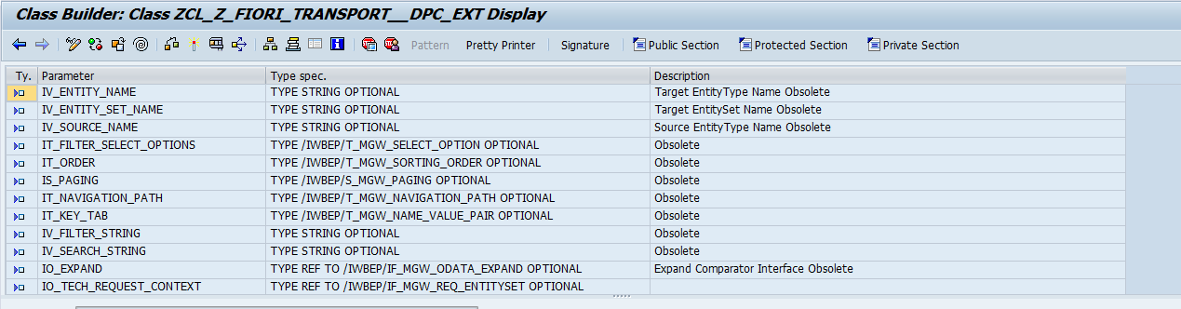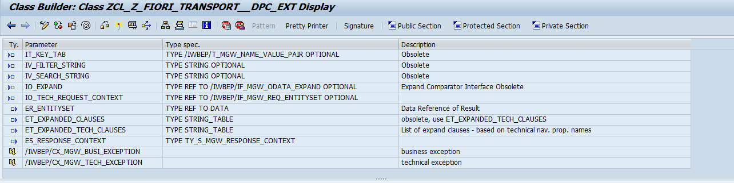

Code:

METHOD /iwbep/if_mgw_appl_srv_runtime~get_expanded_entityset.  
  
  TYPES BEGIN OF ty_schdule.  
          INCLUDE TYPE zcl_z_fiori_transport__mpc=>ts_schedulelist.  
  TYPES: schdeliverynav TYPE STANDARD TABLE OF zcl_z_fiori_transport__mpc=>ts_deliverylist WITH NON-UNIQUE DEFAULT KEY,  
  END OF ty_schdule.  
  
  DATA: ls_schdule TYPE ty_schdule,  
        lt_schdule TYPE TABLE OF ty_schdule,  
        lt_final TYPE ztt_tr_courier_track1,  
        lw_schdule TYPE zst_tr_courier_track1,  
        lt_delivery TYPE ztt_del_det,  
        lw_delivery TYPE zst_del_det,  
        ls_delivery TYPE zcl_z_fiori_transport__mpc=>ts_deliverylist.  
  
  DATA: ls_filter TYPE /iwbep/s_mgw_select_option,  
        ls_filter_range TYPE /iwbep/s_cod_select_option,  
        lt_date TYPE efg_tab_ranges,  
        ls_date LIKE LINE OF lt_date,  
        lv_fromdate TYPE tvarv_val,  
        lv_todate TYPE tvarv_val,  
        lv_mode TYPE char3.  
  
  DATA:      lw_return     TYPE bapiret2,  
             lt_return     TYPE STANDARD TABLE OF bapiret2,  
             ls_key_tab    TYPE /iwbep/s_mgw_name_value_pair,  
             lo_container  TYPE REF TO /iwbep/if_message_container.  
  
  CONSTANTS: lc_expanded_tech_clauses TYPE string VALUE 'SCHDELIVERYNAV',  
             lc_e TYPE char01 VALUE 'E'.  
  
  LOOP AT it_filter_select_options INTO ls_filter.  
    CASE ls_filter-property.  
  
      WHEN 'FromDate'.  
*        loop at ls_filter-select_options into  
        READ TABLE ls_filter-select_options INTO ls_filter_range INDEX 1.  
        IF sy-subrc = 0.  
          lv_fromdate = ls_filter_range-low.  
        ENDIF.  
  
      WHEN 'ToDate'.  
*        loop at ls_filter-select_options into  
        READ TABLE ls_filter-select_options INTO ls_filter_range INDEX 1.  
        IF sy-subrc = 0.  
          lv_todate = ls_filter_range-low.  
        ENDIF.  
  
      WHEN 'Mode'.  
*        loop at ls_filter-select_options into  
        READ TABLE ls_filter-select_options INTO ls_filter_range INDEX 1.  
        IF sy-subrc = 0.  
          lv_mode = ls_filter_range-low.  
        ENDIF.  
    ENDCASE.  
  ENDLOOP.  
  
  IF lv_fromdate IS NOT INITIAL.  
    ls_date-sign = 'I'.  
    ls_date-option = 'BT'.  
    ls_date-low = lv_fromdate.  
    ls_date-high = lv_todate.  
    APPEND ls_date TO lt_date.  
    CLEAR ls_date.  
  ENDIF.  
  
  
  
  CALL FUNCTION 'ZTR_SCH_LIST'  
    EXPORTING  
      s_date      = lt_date  
*     S_STO       =  
*     S_VBELN     =  
*     S_STN       =  
      iv_mode     = lv_mode  
    IMPORTING  
      lt_final    = lt_final  
*     LT_F4       =  
      lt_delivery = lt_delivery  
      et_return   = lt_return.  
  
  
*  SORT lt_final BY vbelnd.  
*  DELETE ADJACENT DUPLICATES FROM lt_final COMPARING vbelnd.  
  
  LOOP AT  lt_final INTO lw_schdule.  
    ls_schdule-vbeln = lw_schdule-vbeln.  
    ls_schdule-posnr = lw_schdule-posnr.  
    ls_schdule-vbelnd = lw_schdule-vbelnd.  
    ls_schdule-zshtyp = lw_schdule-zshtyp.  
    ls_schdule-zshtyp_descr = lw_schdule-zshtyp_descr.  
    ls_schdule-confdat = lw_schdule-confdat.  
    ls_schdule-sysid = lw_schdule-sysid.  
    ls_schdule-grpid = lw_schdule-grpid.  
    ls_schdule-route = lw_schdule-route.  
    ls_schdule-stageseq = lw_schdule-stageseq.  
    ls_schdule-kunnr = lw_schdule-kunnr.  
    ls_schdule-name1 = lw_schdule-name1.  
    ls_schdule-zzdropseq = lw_schdule-zzdropseq.  
    ls_schdule-stn_no = lw_schdule-stn_no.  
    ls_schdule-city = lw_schdule-city.  
    ls_schdule-pgi_status = lw_schdule-pgi_status.  
    ls_schdule-pstyv = lw_schdule-pstyv.  
    ls_schdule-werks = lw_schdule-werks.  
    ls_schdule-vstel = lw_schdule-vstel.  
    ls_schdule-werks1 = lw_schdule-werks1.  
    ls_schdule-inco1 = lw_schdule-inco1.  
    ls_schdule-type = lw_schdule-type.  
    ls_schdule-btgew = lw_schdule-btgew.  
    ls_schdule-ntgew = lw_schdule-ntgew.  
    ls_schdule-gewei = lw_schdule-gewei.  
    ls_schdule-kwmeng = lw_schdule-kwmeng.  
    ls_schdule-meins = lw_schdule-meins.  
    ls_schdule-xblnr = lw_schdule-xblnr.        "++Pavan on 12-02-2019  
  
  
    LOOP AT lt_delivery INTO lw_delivery WHERE vbelnd = lw_schdule-vbelnd.  
*READ TABLE lt_delivery into lw_delivery with key vbelnd = lw_schdule-vbelnd.  
  
      ls_delivery-vbelnd = lw_delivery-vbelnd.  
      ls_delivery-posnrd = lw_delivery-posnrd.  
      ls_delivery-kwmeng = lw_delivery-kwmeng.  
      ls_delivery-meins = lw_delivery-meins.  
      ls_delivery-maktx = lw_delivery-maktx.  
      APPEND ls_delivery TO ls_schdule-schdeliverynav.  
*      DELETE lt_delivery where vbelnd = ls_delivery-vbelnd and posnrd = ls_delivery-posnrd.  
      CLEAR: ls_delivery, lw_delivery.  
    ENDLOOP.  
  
  
    APPEND ls_schdule TO lt_schdule.  
    CLEAR: ls_schdule, lw_schdule.  
  ENDLOOP.  
  
*  SORT lt_schdule BY grpid vbelnd.  
  
  IF lt_return IS NOT INITIAL.  
    lo_container = me->mo_context->get_message_container( ).  
    CLEAR lw_return.  
    LOOP AT lt_return INTO lw_return WHERE type = lc_e.  
      CALL METHOD lo_container->add_message  
        EXPORTING  
          iv_msg_type   = lw_return-type  
          iv_msg_id     = lw_return-id  
          iv_msg_number = lw_return-number  
          iv_msg_text   = lw_return-message  
          iv_msg_v1     = lw_return-message_v1  
          iv_msg_v2     = lw_return-message_v2  
          iv_msg_v3     = lw_return-message_v3  
          iv_msg_v4     = lw_return-message_v4.  
    ENDLOOP.  
  
    RAISE EXCEPTION TYPE /iwbep/cx_mgw_busi_exception  
      EXPORTING  
        message_container = lo_container.  
  ENDIF.  
  
  copy_data_to_ref( EXPORTING is_data = lt_schdule  
                  CHANGING cr_data = er_entityset ).  
  
  INSERT lc_expanded_tech_clauses INTO TABLE et_expanded_tech_clauses.  
  
ENDMETHOD.